| **Name : Yash Sarang** | **Class/Roll No. : D16AD / 47** | **Grade :** |
| --- | --- | --- |

**Title of Experiment :**

Multilayer Perceptron algorithm to Simulate XOR gate

**Objective of Experiment :**

Lab Objectives:

1 To implement basic neural network models for simulating logic gates.

2 To implement various training algorithms for feedforward neural networks.

3 To design deep learning models for supervised, unsupervised and sequence learning.

**Outcome of Experiment :**

Lab Outcomes: At the end of the course, the students will be able to

1 Implement basic neural network models to learn logic functions.

2 Design and train feedforward neural networks using various learning algorithms.

3 Build and train deep learning models such as Auto encoders, CNNs, RNN, LSTM etc.

**Problem Statement :**

Design and implement a Multilayer Perceptron (MLP) algorithm to simulate the XOR gate, a classic problem in neural network theory. The goal is to create a neural network architecture that can accurately mimic the behavior of the XOR gate, a non-linearly separable binary function.

**Description / Theory :**

**XOR gate**

The XOR gate, short for "exclusive OR," is a fundamental logical operator used in digital electronics and binary systems. It takes two binary inputs, typically represented as 0 and 1, and produces a single binary output. The XOR gate output is 1 (true) when the number of true inputs is odd. In other words, if exactly one of the inputs is 1, the XOR gate outputs 1; otherwise, it outputs 0.

**Multi-Layer Perceptron (MLP)**

The Multi-Layer Perceptron (MLP) is a fundamental type of artificial neural network architecture used for a variety of machine learning tasks. Comprising an input layer, hidden layers, and an output layer, MLPs process data through interconnected nodes with adjustable weights and biases. These nodes employ activation functions, such as sigmoid or ReLU, to introduce non-linearity and model complex patterns within the data.

**Flowchart** :

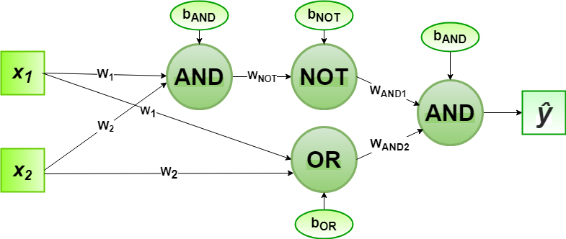

| **Program:**      **Output:** |
| --- |

**Results and Discussions :**

The Multilayer Perceptron (MLP) algorithm was successfully implemented to simulate the XOR gate. Through a series of training epochs, the network's weights and biases were iteratively adjusted to minimize the error between predicted and target outputs for the XOR gate's input combinations. As a result, the network exhibited convergence, accurately predicting XOR gate outputs for inputs [0, 0], [0, 1], [1, 0], and [1, 1], which converged to the expected values of 0, 1, 1, and 0 respectively.

Looking ahead, there are intriguing avenues to enhance the capabilities of the Multi-Layer Perceptron (MLP) beyond its current application in simulating logical operations like the XOR gate. One exciting direction involves investigating more intricate network architectures, such as deeper and wider MLPs, which could enable the handling of increasingly complex datasets and the extraction of higher-level features. Incorporating techniques like dropout and batch normalization can contribute to improved training stability and generalization, reducing the chances of overfitting, and making the MLP more robust.

**Conclusion :**

exploring alternative activation functions, such as Rectified Linear Units (ReLUs) and variants, could potentially mitigate the vanishing gradient problem and promote faster convergence. This exploration of architectural variations and enhancement strategies aligns with the ongoing effort to uncover the MLP's full potential, broadening its applicability across domains like computer vision, natural language processing, and pattern recognition.

**\*\*\*\*\*\***